Project Initiation Document
[PROJECT TITLE]
[MONTH YEAR]

- Background
  - Strategic priority
Outline the strategic context (the situation, policy drivers, and organisation’s strategic priorities).
[INSERT STRATEGIC PRIORITY]
  - The need for change
Outline the need for change. Consider the various sources of insight (data and evidence, feedback from people who use and deliver services, and external drivers).
[INSERT THE NEED FOR CHANGE]
  - Current state
Outline the current state e.g. how does the current pathway, service, process, or way of working currently operate.
[INSERT CURRENT STATE]
  - Evidence base
Outline any existing evidence for doing things differently.
[INSERT EVIDENCE BASE]
  - Learning from previous work
Outline any learning from previous work that has helped to shape and inform this project.
[INSERT LEARNING FROM PREVIOUS WORK]

- Vision and purpose, aim and objectives
  - Vision and purpose
Outline the clear vision (the desired future) and purpose (the reason) for the change.
[INSERT VISION AND PURPOSE]
  - Aim and objectives
Outline the project aim (what the project hopes to achieve), considering what is currently happening (strategic context and current state) and the associated problems (health and social care system needs).
Outline the project objectives (the specific actions that will help the project to achieve its aim).
The overall aim of the project is to [INSERT AIM].
This aim is underpinned by the following objectives:
- [INSERT OBJECTIVE]
- [INSERT OBJECTIVE]

- Outcomes and measures
Outline the anticipated project outcomes (the benefits of the change or the difference it will make) and key measures (how you will know if the change has been a success).
The table below outlines the anticipated short-, medium- and long-term outcomes that will result from the project and key outcome measures.
SHORT-TERM OUTCOMES | MEDIUM-TERM OUTCOMES | LONG-TERM OUTCOMES
IMMEDIATE CHANGES IN KNOWLEDGE, SKILLS, OR ATTITUDES | CHANGES IN PRACTICE, POLICY, OR BEHAVIOUR | THE IMPACT OF THE PROJECT ON PEOPLE/THE POPULATION AND THE HEALTH AND SOCIAL CARE SYSTEM
OUTCOMES
- [INSERT OUTCOME] | - [INSERT OUTCOME] | - [INSERT OUTCOME]
MEASURES
- [INSERT MEASURE] | - [INSERT MEASURE] | - [INSERT MEASURE]

Additional project documents you may wish to develop:
  - A logic model setting out the theory of change.
  - A measurement plan setting out the quantitative and qualitative data and evidence that will be collected to understand what is working and not working in the change.
  - An evaluation plan to understand the impact of the change project. This will help to understand the potential for scalability and spread.

- Scope and exclusions
Outline the project scope (what the project includes) and exclusions (what the project does not include). Be explicit about what is beyond the project boundaries such as specific activities, services, or future phases of work that are not included.
[INSERT SCOPE AND EXCLUSIONS]

- Deliverables and outputs
Outline the project deliverables (the tangible or intangible items that the project will create e.g. a new pathway or service, an improved process, or a culture change).
Outline the project outputs (the smaller items developed along the way that will contribute to those deliverables e.g. new ways of working, training material, systems or tools, or changes to the physical environment).
The project will deliver:
- [INSERT DELIVERABLE]
  - [INSERT OUTPUT]
  - [INSERT OUTPUT]
- [INSERT DELIVERABLE]
  - [INSERT OUTPUT]
  - [INSERT OUTPUT]

- Constraints
Outline the constraints (the restrictions or fixed limitations) that will impact what the project can realistically achieve.
The project has the following constraints:
CONSTRAINTS
Timescales  (the project deadline, especially if there is time-limited funding) | - The project must be delivered by [INSERT END DATE].
Budget/funding  (the internal budget or external funding available for the project) | - The project must be delivered within a budget/available funding of £[INSERT BUDGET/FUNDING].
Scope  (the required project deliverables and outcomes) | - The scope of the project is as per sections 3-5 above.
Quality  (the quality standards the project deliverables must meet e.g. policy requirements, regulatory requirements, what is acceptable to people who access, use, deliver, and support services) | - The project deliverables must meet the following quality standards:  - [INSERT QUALITY STANDARD]
Resources  (the resources available e.g. people, equipment, and information) | - The following resources are available for the project:  - [INSERT RESOURCE]
Risk  (the risk tolerance or level of uncertainty accepted) | - The project will accept the following level of uncertainty:  - [INSERT LEVEL OF UNCERTAINTY]
[INSERT CONSTRAINT TYPE] | - [INSERT CONSTRAINT]

- Interfaces
Outline the project interfaces (the areas where the project connects, interacts, or relies on other internal or external teams, stakeholders, organisations, programmes, or projects).
The table below outlines the internal and external interfaces this project has and how they will be managed.
INTERFACE | MANAGEMENT ARRANGEMENT
INTERNAL
[INSERT INTERFACE] | - [INSERT MANAGEMENT ARRANGEMENT]
EXTERNAL
[INSERT INTERFACE] | - [INSERT MANAGEMENT ARRANGEMENT]

Additional project documents you may wish to develop:
  - An interface map setting out relevant connections. This will help to understand where you might promote, align, co-ordinate, or collaborate with others in working towards common goals.

- Assumptions
Outline any statements that have been taken as true for the purposes of planning, but which could change later e.g. availability of funding, alignment with policy, the evidence base remains true.
The following statements have been taken as true for the purposes of planning, but could change later:
- [INSERT ASSUMPTION]
- [INSERT ASSUMPTION]

- Approach
Outline the approach/methodology that will be used by the project.
The project will use the Scottish Approach to Change.
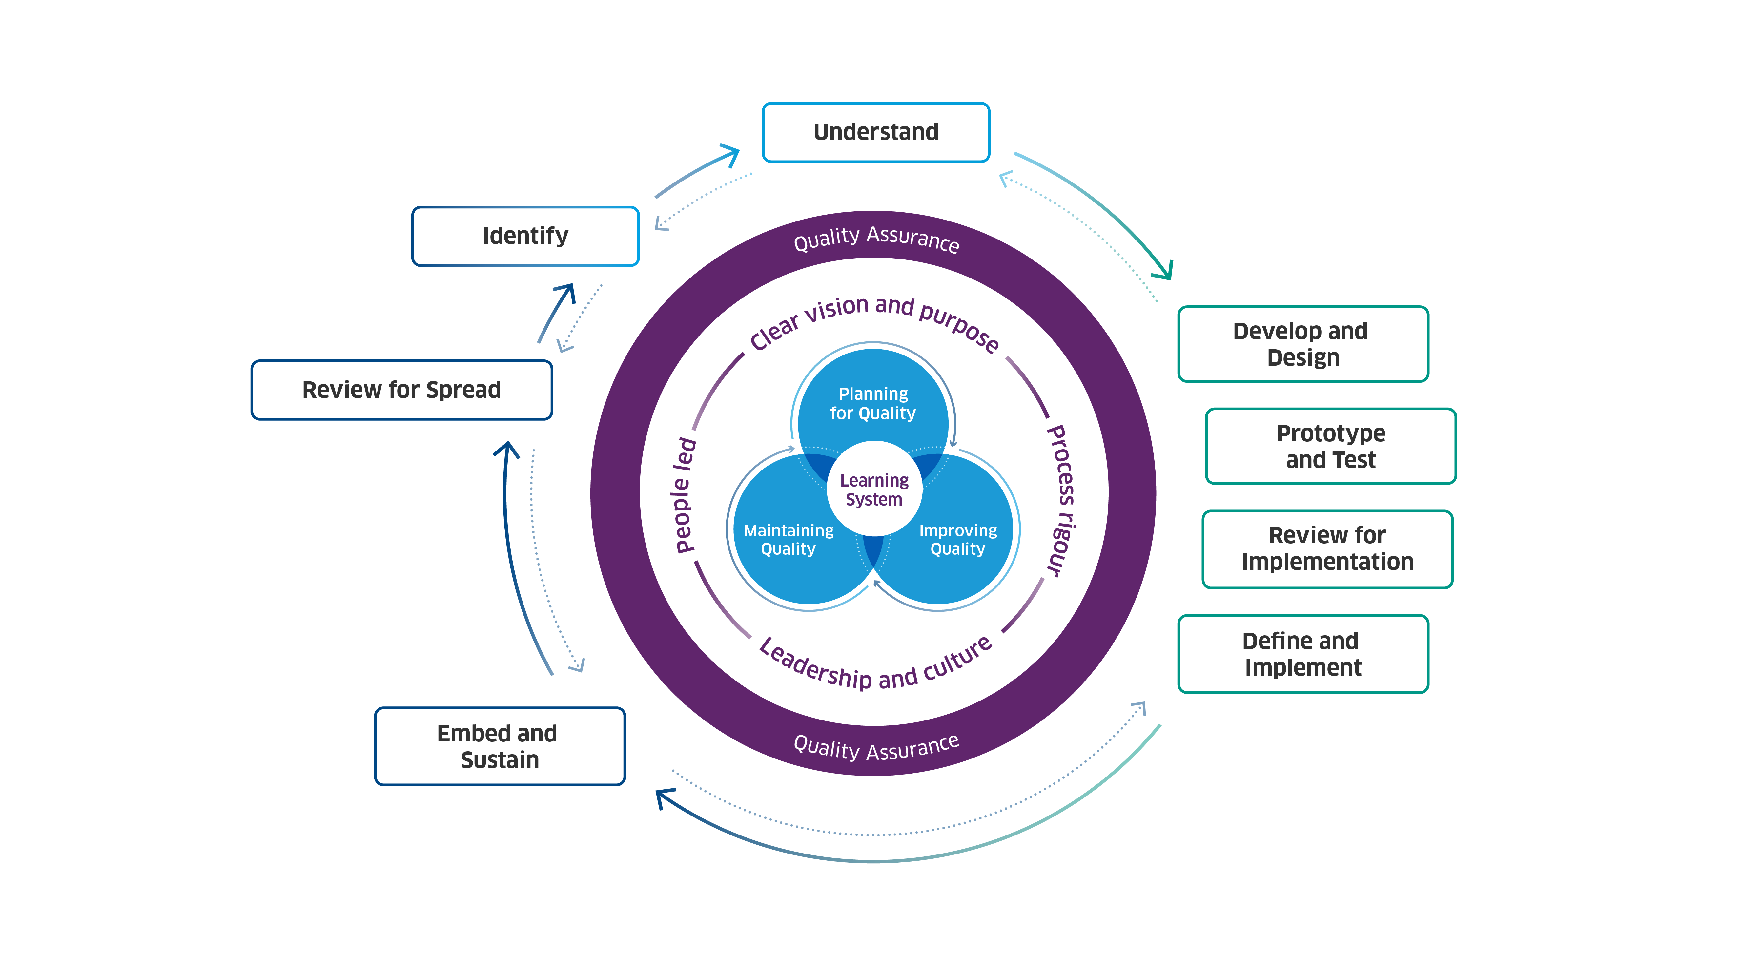
© Healthcare Improvement Scotland. Published: 2025

The project will follow the steps of change:
- Identify – identifying challenges and opportunities through various sources of insight that can reveal opportunities for change.
- Understand – understanding the need for change and the context in which the change is happening so that the right solution and right approach are chosen.
- Develop and design – developing and designing options for change and collaborating with others to develop better solutions.
- Prototype and test – prototyping and testing what works and what does not work, enabling improvement and refinement of the change.
- Review for implementation – reviewing the impact of the change to decide if it will be fully implemented.
- Define and implement – implementing the change and clearly defining new systems and processes that need to be put in place.
- Embed and sustain – embedding and sustaining the change so that it becomes business as usual.
- Review for spread – reviewing whether the change is suitable for spread to other areas and what might be required to do this.
The project will take steps to ensure the enablers of quality and change are in place to create the conditions that support successful and sustainable improvement. The enablers of quality and change are:
- Clear vision and purpose – providing direction, motivation, and alignment.
- Leadership and culture – setting a vision, and inspiring and empowering others.
- Learning system – sharing learning and knowledge to support improvement and better outcomes.
- People led – meaningfully engaging and involving people to help meet their needs.
- Process rigour – going through a structured process to ensure high-quality outcomes.

  - Approach to learning
Outline the structures and processes that will be put in place to gather learning and insights from the project, make sense of them, and act upon/share them.
[INSERT APPROACH TO LEARNING]
Additional project documents you may wish to develop:
  - A learning log to ensure learning is captured and acted upon.
  - A knowledge mobilisation plan outlining how knowledge will be intentionally shared to drive improvement.

- Governance
Outline the governance structures and arrangement which will guide project decision-making, risk management, accountability, and alignment with strategic goals.
The following governance arrangements will be established:
- [INSERT GOVERNANCE ARRANGEMENT]
- [INSERT GOVERNANCE ARRANGEMENT]
Additional project documents you may wish to develop:
  - A visual governance structure showing the how the project will be governed, managed, and supported.
  - Terms of reference for any groups set up to govern the project.

- Clinical governance
Consider how the project will ensure the delivery of safe, effective, and person-centred care and services in line with Healthcare Improvement Scotland’s Clinical Governance Standards. This includes both how the project itself will be delivered e.g. standard 6 and the impact on clinical services because of the change.
The table below sets out Healthcare Improvement Scotland’s Clinical Governance Standards and how we plan to meet these.
STANDARD | HOW THE STANDARD WILL BE MET
Standard 1: Staffing and staff management  Clinical services have effective leadership, oversight, and staffing levels. | - [INSERT HOW THE STANDARD WILL BE MET]
Standard 2: Clinical audit and quality improvement  Clinical services use data and intelligence to monitor and improve the safety and quality of the service. | - [INSERT HOW THE STANDARD WILL BE MET]
Standard 3: Clinical effectiveness  People receive timely, personalised and evidence-based clinical care. | - [INSERT HOW THE STANDARD WILL BE MET]
Standard 4: Risk management and safety  Clinical services monitor practice and respond to safety concerns, risks and near misses. | - [INSERT HOW THE STANDARD WILL BE MET]
Standard 5: Education and training  Staff delivering clinical services have the skills, training, and support to provide safe,  effective and person-centred care. | - [INSERT HOW THE STANDARD WILL BE MET]
Standard 6: Service user and patient involvement  Clinical services involve people and communities in the design and delivery of services. | - [INSERT HOW THE STANDARD WILL BE MET]
Standard 7: Data and information  Clinical services store and share personal data appropriately and use safe, secure systems and tools. | - [INSERT HOW THE STANDARD WILL BE MET]

- Resources
Outline the funding available for the project, indicative budget, and the human and physical resource requirement.
[INSERT RESOURCES]

- Project plan
Outline the high-level project plan including project stages, workstreams, key activities, timelines, and key milestones. NOTE: you may not be able to do this for the entire change cycle – you may only be able to plan for the next step in detail e.g. the Understand step. The project plan should be a live document which is updated regularly as the project progresses.
[INSERT PROJECT PLAN DETAILS]
Additional project documents you may wish to develop:
  - A detailed project plan/Gantt chart setting out project stages, workstreams, activities (including any dependencies), timescales, milestones, review points, and responsible officers.
  - An action log to record actions, timescales for completion, and action owners.
  - Progress reports to monitor project status, progress, the achievement of key milestones, risks, and changes to be made to the project to mitigate or solve any problems.
  - An exit plan to ensure effective project closure and sustainability of change.

- Risks
Outline the project risks (uncertain events which, should they occur, will impact on the delivery and success of the project). Detail how risks will be mitigated.
The following risks and mitigations have been identified:
RISK | MITIGATION
[INSERT RISK] | - [INSERT MITIGATION]

Additional project documents you may wish to develop:
  - A risk register to record and assess risks, and identify risk owners, controls, and mitigations.
  - An issue register to record and assess issues, and identify issue owners, and corrective actions.

- Project team structure, roles, and responsibilities
Detail the key people responsible for delivering the project, and the role and responsibilities of each individual. Consider the multidisciplinary team input that will be required.
The key people responsible for delivering the project are outlined below:
NAME | JOB TITLE | PROJECT ROLE
[INSERT NAME] | [INSERT JOB TITLE] | - [INSERT PROJECT ROLE]

Additional project documents you may wish to develop:
  - A RASCI matrix to help clarify roles and responsibilities in the project team including who is Responsible, Accountable, Support, Consulted, and Informed.

- Stakeholders
Identify key people and organisations who have an interest in/will be impacted by the project. Consider people who need and access services (including families, carers, and the wider community). Consider people and organisations who deliver, support, fund, commission, and regulate services.
The following people and organisations have an interest in/will be impacted by the project:
- [INSERT STAKEHOLDER]
- [INSERT STAKEHOLDER]
Additional project documents you may wish to develop:
  - A stakeholder map to identify stakeholders and detail the ways in which each stakeholder will be impacted by this project, their level of interest in the project, and the extent to which they will have an influence on the success of the project.

- Stakeholder engagement and communication
Outline how stakeholders will be collaborated with, involved, consulted, or informed as appropriate.
Stakeholders will be engaged and communicated with in the following ways:
- [INSERT STAKEHOLDER ENGAGEMENT AND COMMUNICATION DETAIL]
- [INSERT STAKEHOLDER ENGAGEMENT AND COMMUNICATION DETAIL]
Additional project documents you may wish to develop:
  - A stakeholder engagement and communication plan outlining how different stakeholder groups will be engage with.
  - A project communications summary outlining what you are trying to achieve, how you will achieve it and who you are working with to help stakeholders understand the project.

- Engagement and involvement of people
Outline how people, their families, and carers will be engaged and involved in the project. Consider how you will ensure their engagement and involvement is ethical and risk-assessed, and that adequate trauma-informed controls and safeguards are in place. Consider information governance requirements, including for example the need for a Data Protection Impact Assessment (DPIA). Consider statutory duties to engage and involve people as set out in Planning with People: Community engagement and participation guidance.
The project will engage and involve people, their families, and carers and will ensure their engagement and involvement is ethical, risk- assessed, and trauma-informed in the following ways:
- [INSERT HOW PEOPLE WILL BE ENGAGED AND INVOLVED]
- [INSERT HOW PEOPLE WILL BE ENGAGED AND INVOLVED]
Additional project documents you may wish to develop:
  - A people led engagement plan setting out how people, and their families and carers will be engaged and involved.
  - A user research plan setting out how you will conduct user research to understand the people you’re designing for (i.e. people who use and deliver services) and their needs.

- Equality and human rights
Outline how inequalities and health inequalities will be considered throughout project. Consider The Health and Social Care Standards and The Fairer Scotland Duty will be met. Consider how you will take a human-rights based approach.
The project will embed equality in the following ways:
- [INSERT EQUALITY CONSIDERATION]
- [INSERT EQUALITY CONSIDERATION]
Additional project documents you may wish to develop:
  - An Equality Impact Assessment (EQIA) to identify potential disadvantages and offer an opportunity to take appropriate actions to actively remove or minimise any adverse impact. Your own organisation will have its own equality impact assessment process which you should follow.

- Sustainability
Outline how sustainability will be considered in the design and delivery of the project. This may include financial sustainability, impact on the wider economy (linked to population health, demographic changes, increases in the burden of disease, prevention, and early intervention activity, and increasing inequalities (including health inequalities)), and the impact on the environment.
[INSERT SUSTAINABILITY CONSIDERATIONS]

