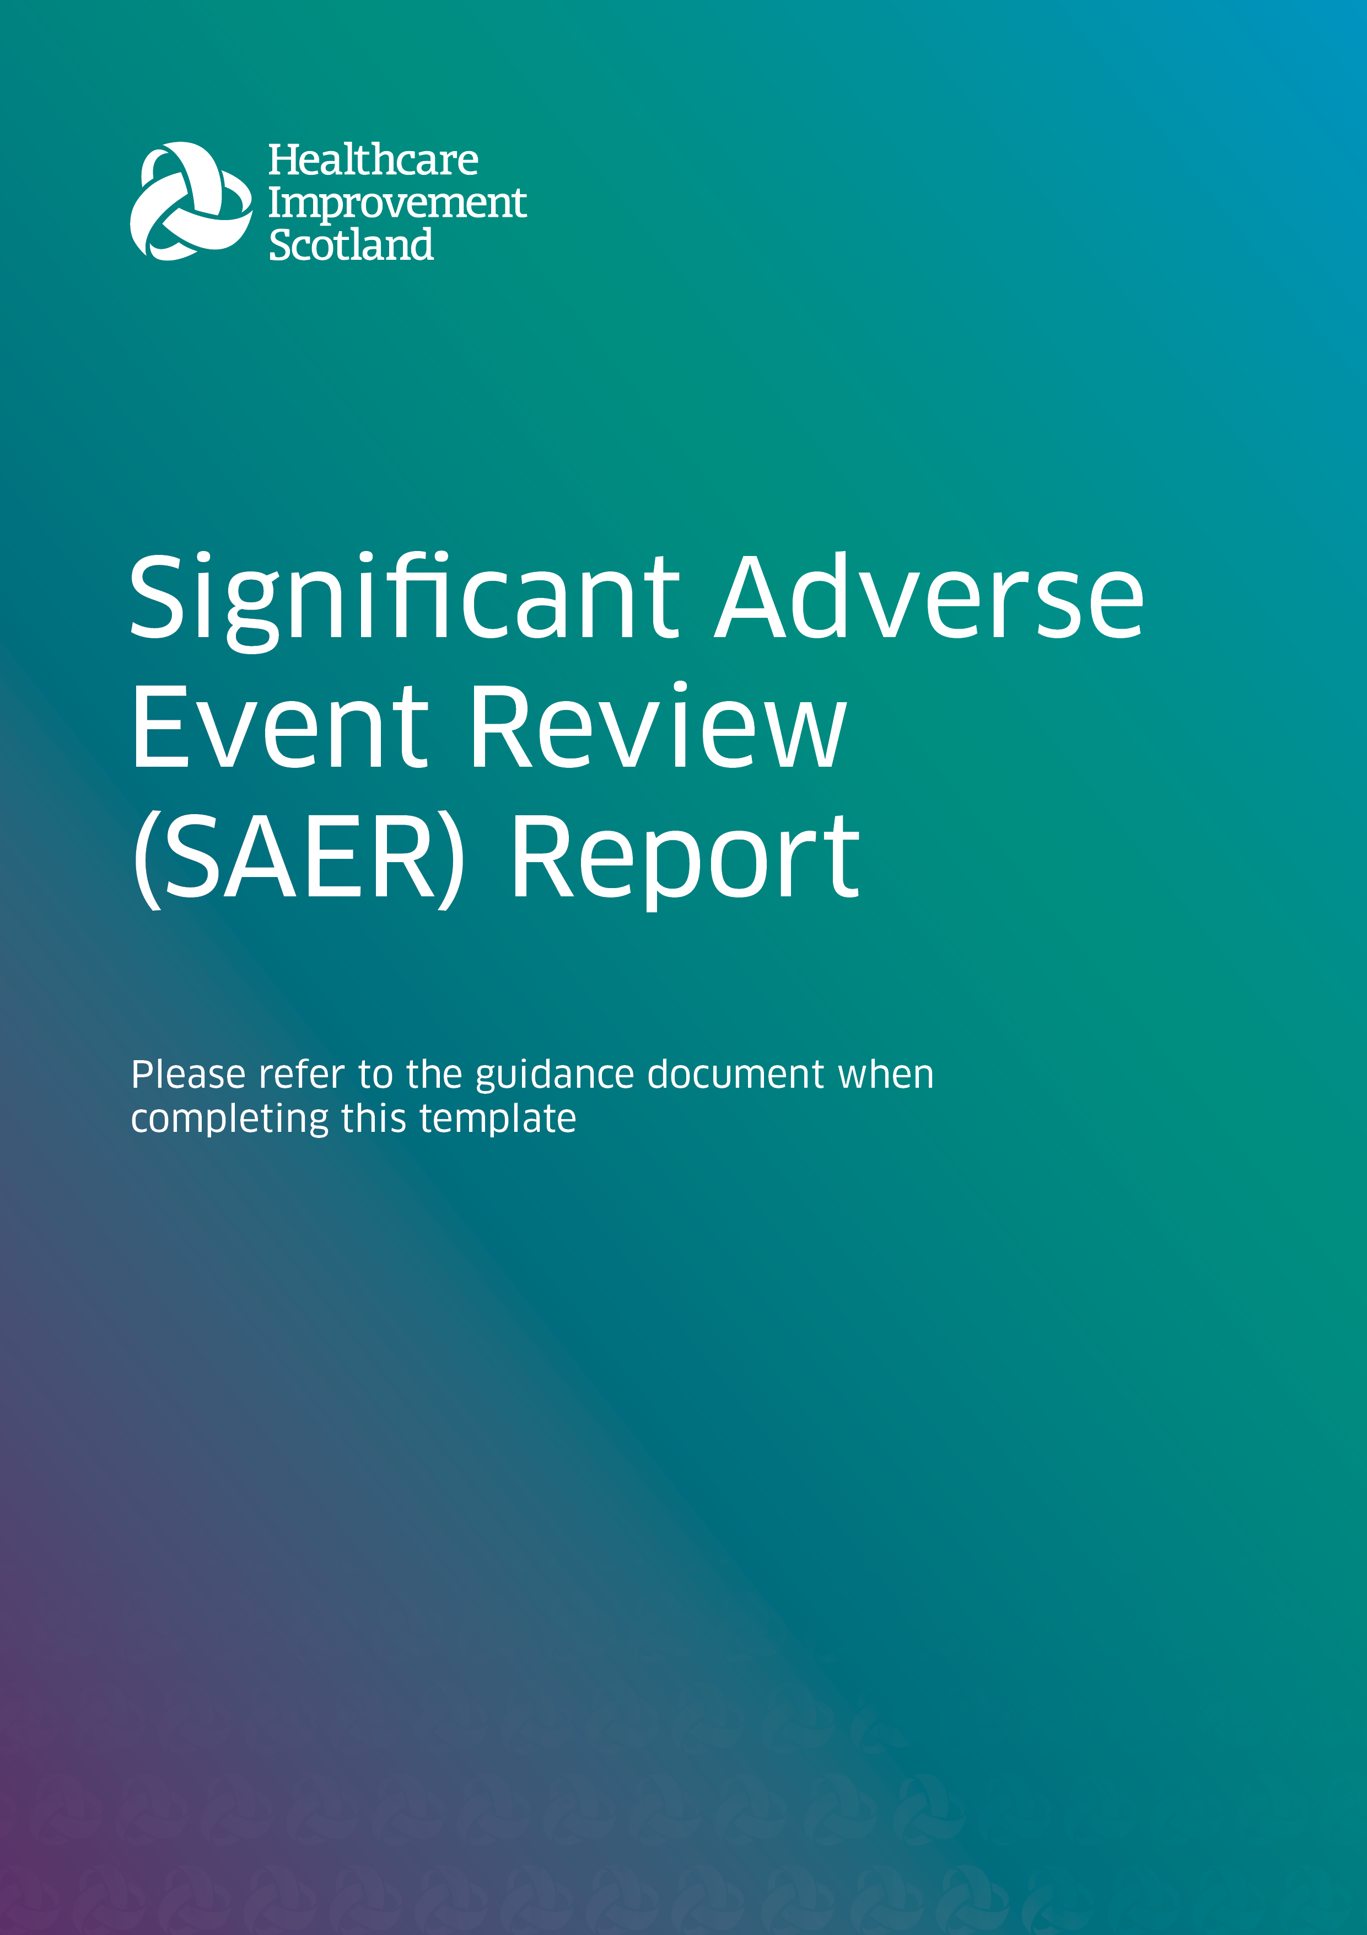

Executive Summary
Adverse event overview:

Key findings:

Summary of recommendations:

Outcome code: Choose an item.

Review Details

Patient/event identifier
Are there relevant equality factors? | Choose an item.
Date of event | Click or tap to enter a date.
Directorate speciality
Date review commissioned | Click or tap to enter a date.
Review commissioned by
Lead reviewer(s)
Named contact for patient/family
Date SAER report completed
Approved by/date
Distribution list and date of sharing

For second NHS board where applicable
NHS board

Acknowledgements

Useful Information

The name the patient/family have agreed the patient will be referred to in the report:

Definitions and Acronyms:

Terms of Reference and Review Process

Method/approach:

Key consideration and questions to be answered:

Period covered by the review:

Staff:

Recording of discussions and review of paperwork:

Show the patient and/or family are involved in the review process

Areas of importance to the patient/family:
(including scope, contact, what matters to them and questions)

Summary of the main findings from discussion with the patient/family:

Description of event

A factual account of what happened, including key dates:

Where did it happen:

Key findings

Analysis of findings including contributory factors:

Areas of good practice:

Learning identified:

Conclusions:

Did an equality factor impact on the outcome? Choose an item.
Does this meet the threshold for Duty of Candour: Choose an item.

Recommendations

References

Appendices

